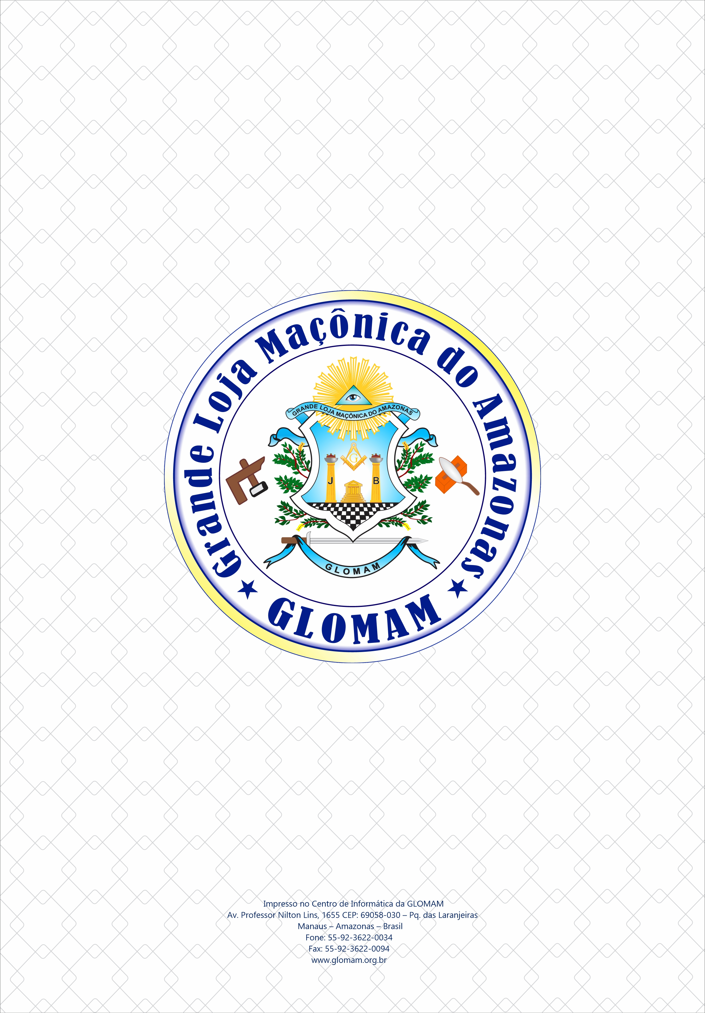
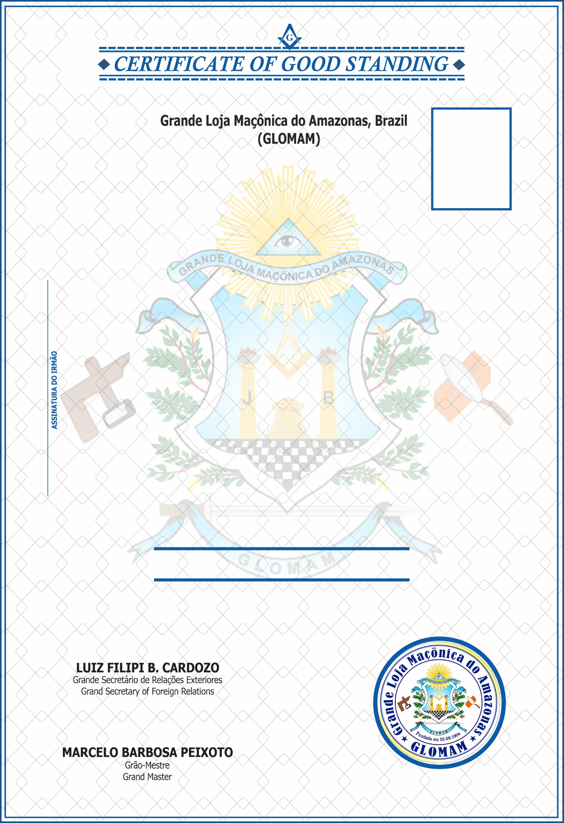

FOTO
Manaus, month day, year.
As provided in the GLOMAM Masonic code, and upon receipt of a proper request, THIS IS TO CERTIFY that Brother NOME COMPLETO DO IRMÃO CIM: 00000 is a Master Mason in good and regular standing and free oh all indebtedness to this Grand Lodge at the date hereof, and that there are no charges on file or pending against him. This certificate shall not be received by a Lodge for purpose of membership.

Given under my hand and the seal of this Grand Lodge, the date and year first above written.
VALID UNTIL: month day, year.

